SIMATS ENGINEERING
ASSESSMENT TOOL 2 : Scenario-Based

COURSE NAME: Cloud Computing and COURSE CODE: CSA15
Big Data Analytics

COURSE OUTCOME COVERED
CO2: Analyze virtualization architectures to identify performance and security issues in cloud computing environments. (BL3)

Dave's Taxonomy: Manipulation (Level 2) Total Marks: 25
Question Count: 5

Code of Conduct
I AMARA SATWIKA (Name / Reg No) certify that this submission is my original work and that I have adhered to the guidelines specified for this assessment.
I understand that any violation of academic integrity rules will result in disciplinary action.
Signature of the student: A.SATWIKA

Assessment Tasks Scenario-Based Questions

- A media company wants to migrate its video streaming platform to the cloud. The system must handle millions of concurrent users with minimal buffering.
Design a cloud architecture using scalability and caching techniques.
Explain how load balancing and auto-scaling can ensure smooth streaming. Discuss cost optimization strategies for such high-demand workloads.
Cloud Architecture for a Video Streaming Platform
Introduction
A media company with millions of concurrent users needs a highly scalable, highly available, and low-latency cloud architecture. The main goal is to reduce buffering and deliver videos quickly to users.

Proposed Architecture
Users
↓
DNS / Route 53
↓
CDN (CloudFront)
↓
Load Balancer
↓
Auto-Scaling Application Servers
↓
Video Storage
Object Store
↓
Metadata Database
1. Scalability
- Use horizontal scaling by adding more application servers when traffic increases.
- Deploy servers across multiple availability zones.
- Use auto-scaling to automatically increase or decrease resources according to demand.
- Store videos in scalable object storage such as Amazon S3, Azure Blob Storage, or Google Cloud Storage.
2. Caching
A Content Delivery Network (CDN) stores frequently accessed video content at locations close to users.
For example:
User → Nearest CDN Edge → Video
Instead of every user requesting the video from the main server, the CDN serves cached content.
Benefits:
- Reduces latency
- Reduces server load
- Minimizes buffering
- Improves global performance
3. Load Balancing
A load balancer distributes user requests among multiple servers.
Load Balancer
/ | \
Server1 Server2 Server3
If one server becomes unavailable, traffic is automatically redirected to healthy servers.
4. Auto-Scaling
Auto-scaling monitors metrics such as:
- CPU utilization
- Number of users
- Network traffic
- Requests per second
During peak hours:
High traffic → Add servers
During low traffic:
Low traffic → Remove servers
This provides performance without permanently running excessive resources.
5. Cost Optimization
- Use CDN caching to reduce origin-server traffic.
- Use auto-scaling to avoid idle servers.
- Use reserved/savings plans for predictable workloads.
- Use spot/preemptible instances for suitable background processing.
- Compress and encode videos using efficient formats.
- Use lifecycle policies to move old videos to cheaper storage.

- A fintech startup is deploying applications using containers across multiple cloud providers.
They face challenges in maintaining consistency and managing deployments.
Propose a solution using container orchestration and multi-cloud strategies.
Explain how service discovery and scaling can be handled efficiently. Highlight the benefits and risks of a multi-cloud deployment model.
Multi-Cloud Container Deployment for a Fintech Startup

Introduction
The fintech startup uses containers across multiple cloud providers but faces problems with deployment consistency and management. A container orchestration platform such as Kubernetes can provide a common management layer.
Proposed Architecture
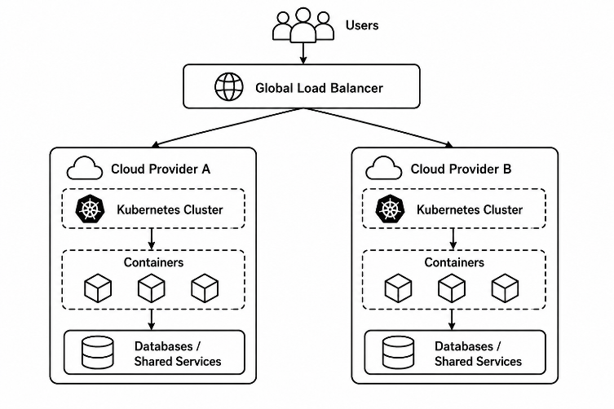
1. Container Orchestration
Use Kubernetes to manage containers.
Kubernetes provides:
- Container deployment
- Scheduling
- Scaling
- Self-healing
- Rolling updates
- Service discovery

Container images can be stored in a common container registry.
Source Code
↓
CI/CD Pipeline
↓
Container Image
↓
Container Registry
↓
Kubernetes Clusters
This ensures the same application version is deployed across different clouds.
2. Consistent Deployment
Use:
- Docker/container images
- Kubernetes manifests
- Helm charts
- Infrastructure-as-Code tools such as Terraform
- CI/CD pipelines
This reduces configuration differences between cloud providers.
3. Service Discovery
Kubernetes provides internal service discovery using Services and DNS.
For example:
Application A
↓
Payment Service
↓
Available Payment Pods
The application does not need to know the individual IP address of every container.
4. Scaling
Kubernetes can automatically scale applications using:
- Horizontal Pod Autoscaler
- Vertical Pod Autoscaler
- Cluster Autoscaler
When traffic increases:
High traffic
↓
More Pods
↓
More processing capacity
5. Benefits of Multi-Cloud
- Reduces dependency on a single cloud provider.
- Improves availability.
- Provides flexibility to select different cloud services.
- Can reduce vendor lock-in.
- Supports disaster recovery.
- Allows workloads to be distributed geographically.
6. Risks
- Higher management complexity.
- Different cloud services and APIs.
- Difficult monitoring across providers.
- Increased networking costs.
- Data synchronization challenges.
- Security and compliance become more complex.

- An e-learning platform experiences data loss due to accidental deletion in the cloud. The organization needs a robust backup and disaster recovery strategy.
Design a solution using cloud-native backup, replication, and versioning.
Explain how recovery time objective (RTO) and recovery point objective (RPO) are achieved. Provide steps to ensure business continuity during failures.

Backup and Disaster Recovery for an E-Learning Platform
Introduction
The e-learning platform has experienced data loss due to accidental deletion. A cloud-native backup and disaster recovery architecture should use backup, replication, versioning, and automated recovery.
Proposed Architecture
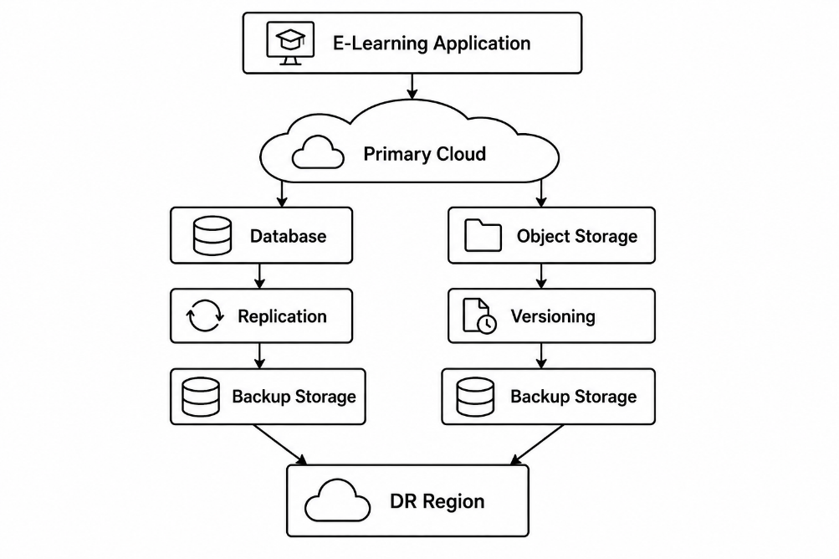

1. Cloud-Native Backup
Regularly back up:
- Databases
- User information
- Course content
- Videos
- Application configurations
Use automated backup schedules instead of manual backups.

2. Versioning
Enable object versioning for important files.
Example:
Course.pdf
↓
Version 1
↓
Version 2
↓
Version 3
If a user accidentally deletes or modifies a file, an earlier version can be restored.
3. Replication
Replicate critical data to another availability zone or region.
Primary Region
↓
Continuous Replication
↓
DR Region
If the primary region fails, the DR environment can be activated.
4. RPO
Recovery Point Objective (RPO) defines the maximum acceptable amount of data loss.
Example:
RPO = 15 minutes
The system should be designed so that at most approximately 15 minutes of recent data is lost after a major failure.
Frequent backups or continuous replication help achieve a low RPO.
5. RTO
Recovery Time Objective (RTO) defines the maximum acceptable time to restore the service.
Example:
RTO = 30 minutes
Automated infrastructure deployment, replicated data, and standby systems help achieve a low RTO.

6. Business Continuity Steps
- Identify critical applications and data.
- Define RTO and RPO.
- Enable automated backups.
- Enable object/file versioning.
- Replicate critical data to a separate region.
- Maintain a disaster recovery environment.
- Automate failover procedures.
- Regularly test backup restoration.
- Monitor backup failures.
- Document recovery procedures.

- A government agency is adopting a hybrid cloud model for sensitive and non-sensitive data. Some applications must remain on-premises due to compliance requirements.
Design a hybrid architecture that ensures secure communication between environments.
Explain how identity management and encryption should be implemented. Discuss challenges in managing hybrid cloud environments.
Hybrid Cloud Architecture for a Government Agency
Introduction
A government agency needs to keep sensitive applications and data on-premises while using the public cloud for non-sensitive workloads. A hybrid cloud architecture provides both security and flexibility.
Proposed Architecture
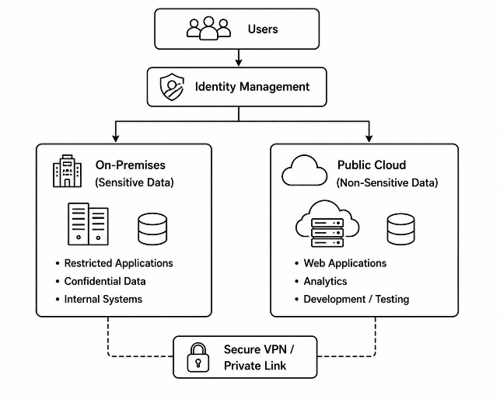
1. On-Premises Environment
Sensitive information such as:
- Government records
- Confidential citizen information
- Restricted applications
can remain in the organization's private datacenter.
2. Public Cloud
The public cloud can host:
- Public websites
- Non-sensitive applications
- Analytics workloads
- Development and testing environments
3. Secure Communication
Use:
- Site-to-site VPN
- Dedicated private connections
- Firewalls
- Network segmentation
- Private endpoints
Communication should be encrypted between the on-premises and cloud environments.
4. Identity Management
Use centralized identity management with:
- Single Sign-On (SSO)
- Multi-Factor Authentication (MFA)
- Role-Based Access Control (RBAC)
- Least-privilege access
Example:
Government Employee
↓
SSO + MFA
↓
Identity Provider
↓
Cloud / On-Premises Resources
Users should receive only the permissions required for their jobs.
5. Encryption
Data at rest:
- Encrypt databases
- Encrypt cloud storage
- Protect backup copies
Data in transit:
- Use TLS/HTTPS
- Use encrypted VPN/private connections
Encryption keys should be securely managed using a Key Management Service (KMS) or equivalent hardware/security solution.
6. Challenges
- Complex network management
- Different security policies
- Identity synchronization
- Monitoring across environments
- Compliance requirements
- Higher operational complexity
- Data synchronization issues

- A SaaS provider needs to ensure high availability and fault tolerance for its application.
The system must continue operating even if one region goes down.
Propose a multi-region deployment strategy in the cloud.
Explain how data replication and failover mechanisms should be configured. Discuss monitoring and alerting strategies for proactive issue detection.
Multi-Region High Availability for a SaaS Provider
Introduction
A SaaS provider must continue operating even if an entire cloud region fails. A multi-region architecture distributes application resources across multiple geographical regions.
Proposed Architecture

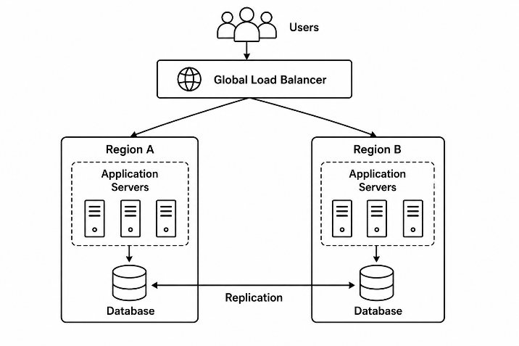

1. Multi-Region Deployment
Deploy the application in at least two regions.
For example:
Region A = Primary
Region B = Secondary
Both regions should have:
- Application servers
- Load balancers
- Databases
- Caching
- Monitoring
For higher availability, both regions can actively serve traffic.
2. Data Replication
Database data should be replicated between regions.
Region A Database
↕
Cross-Region Replication
↕
Region B Database
Replication can be:
- Synchronous
- Asynchronous
Synchronous replication provides stronger consistency but can increase latency.
Asynchronous replication provides better performance but may allow a small amount of recent data loss.
3. Failover Mechanism
A global traffic manager monitors the health of each region.
Normal operation:
Users
↓
Region A
↓
Healthy
If Region A fails:
Users
↓
Global Traffic Manager
↓
Region B
Traffic is automatically redirected to the healthy region.
4. Health Checks
Regularly monitor:
- Server health
- Application availability
- Database health
- CPU and memory
- Network latency
- Error rates
- Request failures
5. Monitoring and Alerting
A centralized monitoring system collects logs and metrics from all regions.
Applications
↓
Monitoring System
↓
Metrics + Logs
↓
Alerts
↓
Operations Team
Alerts should be generated for:
- High error rates
- Increased latency
- Server failures
- Database replication failures
- Region outages
- Unusual traffic patterns
6. Fault Tolerance
Use:
- Multiple availability zones
- Redundant servers
- Auto-scaling
- Replicated databases
- Load balancing
- Automated failover
- Health checks
7. Benefits
- High availability
- Reduced downtime
- Disaster recovery
- Better global performance
- Fault tolerance
- Improved customer experience

Scenario-Based Rubric

Criteria | Weightage | Level 4 -  Exemplary | Level 3 -  Proficient | Level 2 -  Developing | Level 1 -  Beginning
Understanding of Scenario | 20% | Demonstrates complete understanding of the scenario context | Good understanding with minor gaps | Partial understanding | Fails to understand the scenario
Identification of Risks / Issues | 20% | Identifies all major issues correctly | Identifies most issues | Limited issue identification | Misses major issues
Application of Concepts | 25% | Applies virtualization concepts effectively | Applies concepts with minor mistakes | Partially correct application | Weak  application
Decision  Justification | 20% | Decisions are well justified and technically strong | Reasonable  justification | Weak  justification | No useful justification
Clarity | 15% | Clear and well-organized response | Generally clear | Somewhat  unclear | Poorly presented

